Why iOS Developers are moving to Swift?

Time to move to Swift and replace C! Attention, iOS app developers and companies, it’s time to realize the benefits of Swift programming language and shift to it. Swift replaced C for embedded programming on Apple platforms. Moreover, it is best replacement of Objective-C in [app development for MAC, iPhone, iPad, Apple Watch](http://www.evincedev.com/iphone-mobile-app-development) etc.

Over 4 years of research, it’s finally the time when Swift can be used with Apple products based on Objective-C, it is also used in sync with Apple’s Cocoa and Cocoa Touch frameworks. Let’s learn and understand why iOS developers should shift to Swift in iOS App Development.

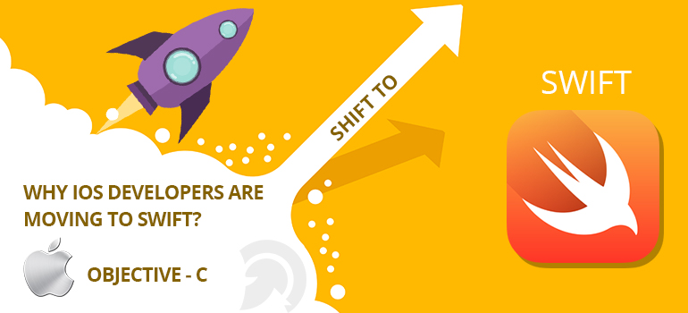

**Swift Programming Language**

Swift is a coding language created for iOS, OS X development by Apple Inc. which is designed to work with Apple’s Cocoa Touch frameworks.

**Let’s understand why Swift?**

End your confusions here and just understand why to adopt Swift over Objective-C Below are few things/reasons of why to move to the swift.

**Interoperability and Compatibility:** There is an interface between Objective-C and Swift which helps to make the best designs and programming practices. Developers can use codes written in Objective-C in Swift. Swift apps are compatible with latest iOS versions, OS X Yosemite and OS X Mavericks.

**It is Speedier:** App developers enjoy writing codes for Swift apps as they are easier. Apple is focused on improving the speed at which Swift can run the logic. Programming is faster as they do not have to import references for setting up the main function. Libraries handle most of the OSX and iOS user references which result in agile app development. Apple says programs written in Swift will run 73% faster as compared to those written in Objective-C.

**It is easy to read:** Unlike C Swift can unify all the keywords and symbols in every Objective-C type or object related keywords so there is no need for semicolons to end lines or parentheses to put conditional expressions in if/else statements. Swift code more closely resembles natural English, in addition to other modern popular programming languages. This readability makes it easier for existing programmers from JavaScript, Java, Python, C#, and C++ to adopt Swift.

**It is Safe:** Swift is a strongly restricted typed language and it’s default setting is always in place, preventing the false coding due to faulty input. Swift generates a compiler error AS when you write a bad code. Moreover, it reduces the resources spent on bug fixing. Swift prompts a runtime crash that provides consistent behavior forcing the developer to fix the issue immediately. Type inference makes Swift type safe. This feature reduces code length.

**Lesser Code and Quicker Development:** Swift is a programming language which differentiates itself by reducing the amount of coding required for repetitive statements and string management. It has adopted features that are seen in modern day programming languages, for example, two strings can simply be added together with a “+” operator. We can combine two pieces of information is quite a tedious task in Objective-C as there are many steps to be taken.

**Faster Release and Quicker Updates:** The lengthy bug fixes and development processes are eliminated, for an [App development company](http://www.evincedev.com/) Swift saves time and man hours. The simpler the code, the smoother the reuse. Due to codes being simple, programmers spend less time on its reuse and can roll out updates (and new app versions) quite frequently.

There is much more than this. Swift had been into developer's mind and now they can’t code without using it. After considering so many benefits and reasons, Swift is obvious to use. It has given developers a motivation to create competitive apps in less time.

Find a team of iOS developers who are expert and comfortable in using swift and made edge winning apps over a short period of time. Now fresher’s, developers, companies, and independent app makers everyone can move to Swift and bring their talent out to the world.

Source:

<http://www.evincedev.com/why-ios-developers-are-moving-to-swift>

**Contact Us:**

**Visit our official website:** [www.evincedev.com](http://www.evincedev.com)

**Email:** [Padnya.maulik@gmail.com](mailto:Padnya.maulik@gmail.com)

**Skype:** evince.development

**Contact:** +1 315 715 8494

+61 416 474 542

+39 3921722826

[](https://www.facebook.com/EvinceDevelopment) [](https://twitter.com/evincedev) [](https://www.linkedin.com/company/evince-development)